

**Integrated Excise Management System (IEMS)**

**Excise Automation (EA)**

**User Guide**

Table of Contents

1. Objective : 3

2. EA Masters 4

3. Grain/Molasses based distillery 15

3.1 Indent for Molasses (MF1) 15

3.2 Allocation Request 16

3.3 Release Request 18

3.4 NOC 18

3.5 Pass 20

4. Sugar Cane Factory 21

4.1 Form R G 4 21

4.2 Daily Molasses Production 22

4.3 Molasses Issue Register 23

6. Dispatch Process 30

6.1 Distillery Dispatch Permission / Approval 30

6.2 Molasses Dispatch Permission / Approval 31

6.3 Bottling Dispatch Permission / Approval 32

7. SCM Reports 33

# 1. Objective :

Objective of this document is to provide a user guide on how to use the Excise Automation module in Effective manner for both Admin login as well as for Excise Department User login.

Dashboard

The Dashboard displays the following:

# The general flow of the program in this system will be that the user will be presented with the list of all the data entered. The detail form will be shown to the user depending on the View or Edit button clicked.

**All captions for required field are prefixed with an red asterisk**

# 2. EA Masters

2.1 Party Type Master

This form will be used to create new Party Type Information.

This is an Admin Function and no users will have access to this screen.

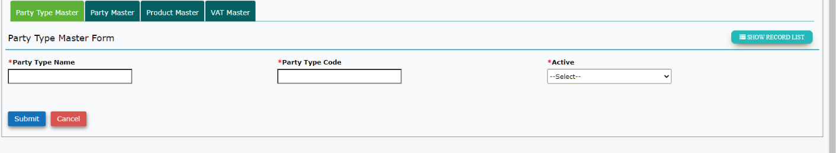

**Form Field and their Functionality**

*Party type Name : Valid types are **Sugar Mill, Distilleries & Breweries**

*Party type code : Code of the Sugar Mill or Distillery

*Active : If the party type is active

# 3.1 Indent for Molasses (MF1)

This option is used by the Distillery to request an Indent for Molasses. This can be done only once per year

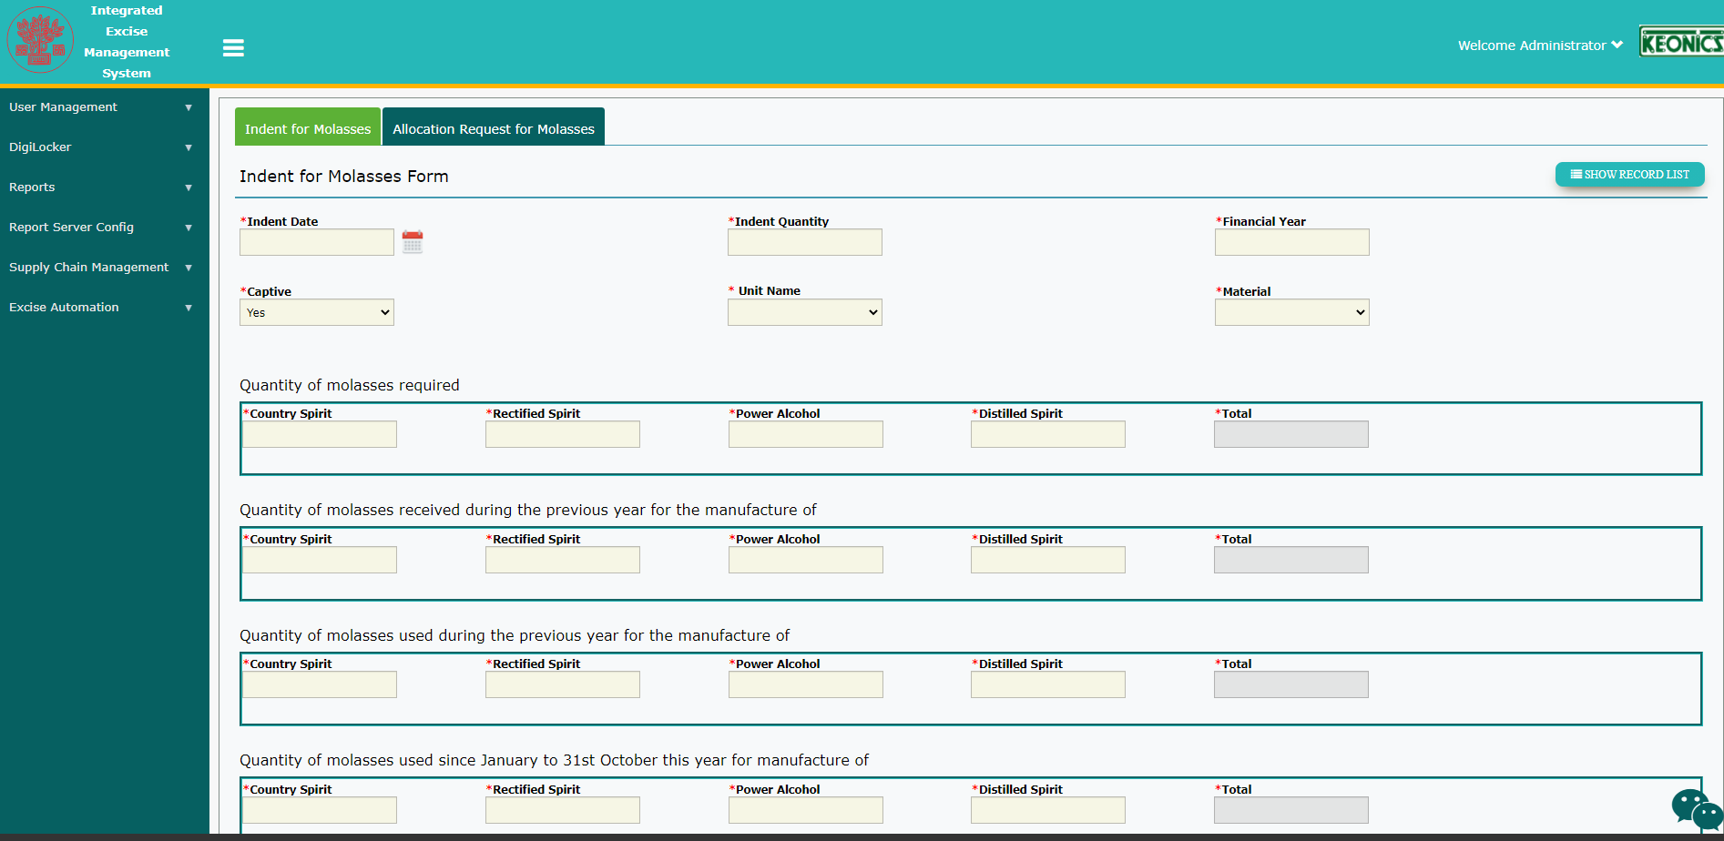

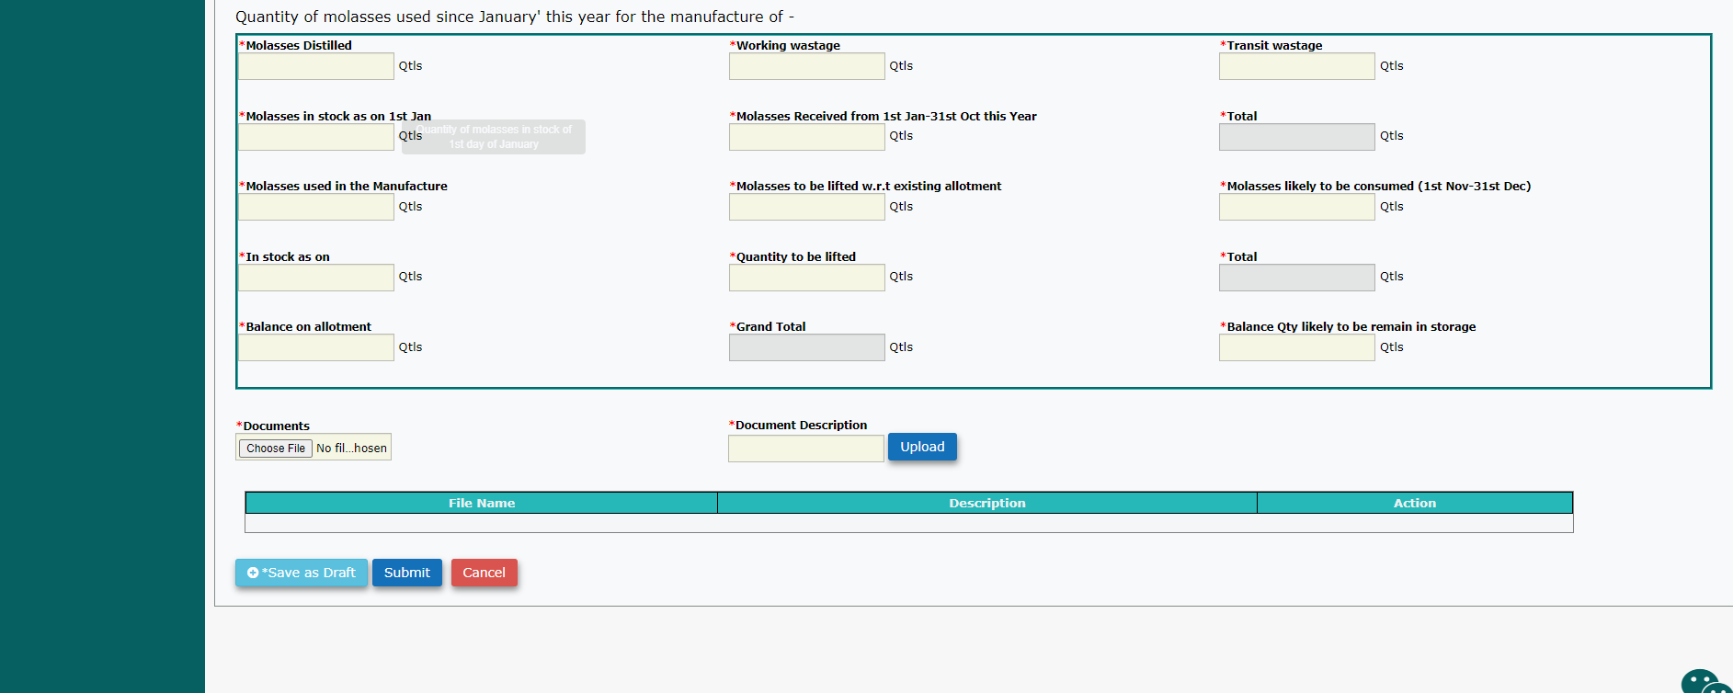

**Form Field and their Functionality**

*Indent Qty : User Input

Financial Year : Readonly. To pick the current financial year from party_master

Indent Date : Current Date. Readonly.

Captive : User Input

Captive Unit Name : User Input. Readonly if Captive is No

Material : User Input. Dropdown. Should only show the Molasses Type Available for this particular party.

C.S,R.S,P.A,D.S : User Input

Molasses Distilled : User Input

Working Wastage : User Input

Transit Wastage : User Input

Molasses in Stock : User Input

Molasses Received : User Input

Molasses Used : User Input

Molasses to be lifted : User Input

Molasses to be cons. : User Input

Current Stock : User Input

Qty to be lifted : User Input

Bal on Allotment : User Input

Storage Balance : User Input

Remarks : User Input

**Validations required on the form**

1. You can have only **one record per financial year** per party

# 3.2 Allocation Request for Molasses

This form is used by the Distillery to request an Allocation of Molasses from the department. The request can be done from its own captive unit or from some other sugar mill.

This allocation request needs to be approved by the commissioner and then issued by the Deputy Commissioner.

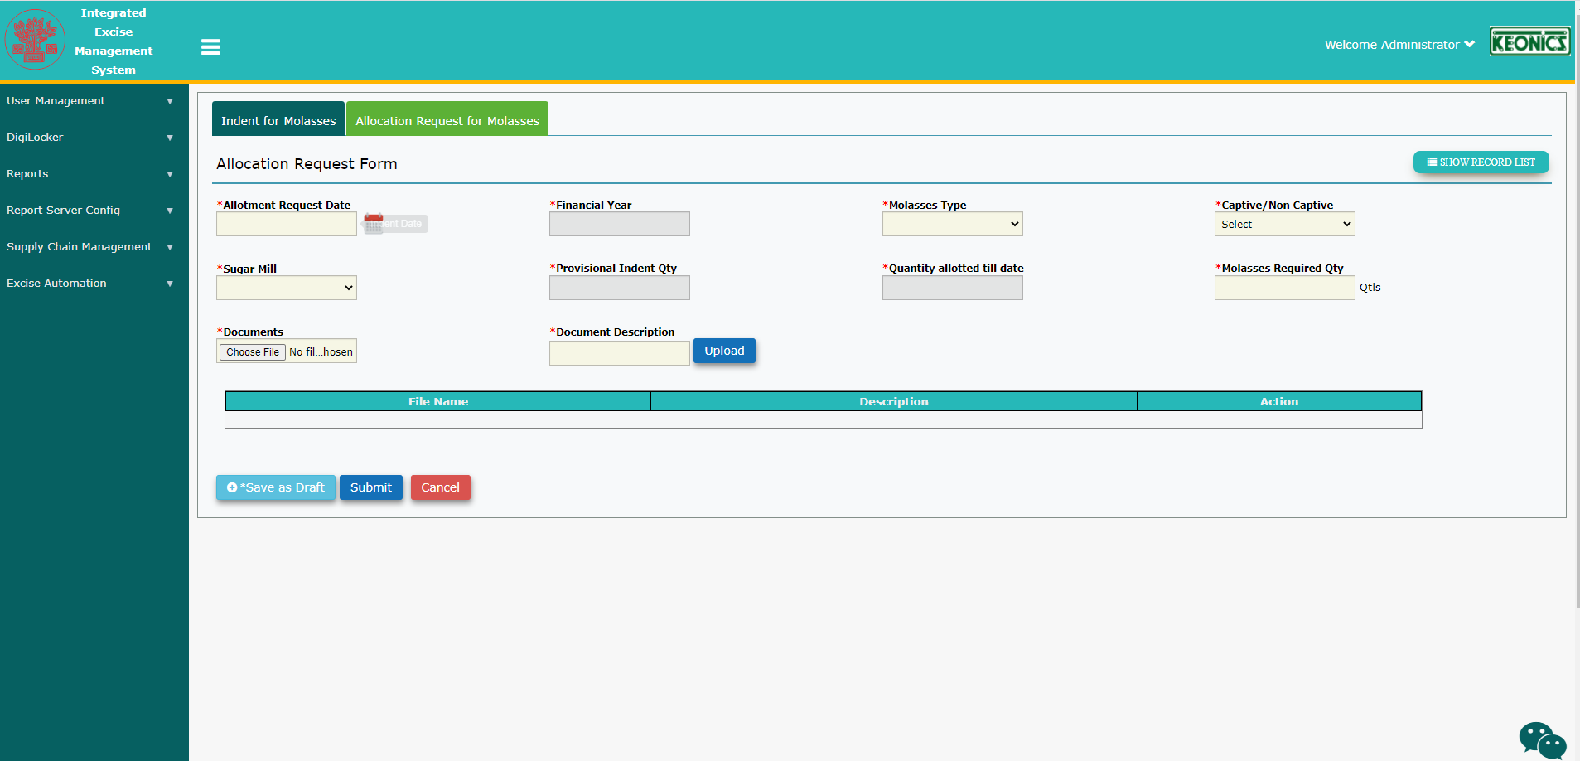

**Form Field and their Functionality**

*Allotment Request Date : User Input

Financial Year : Readonly. To pick the current financial year from party_master

Indent Date : Current Date. Readonly.

Captive : User Input

Captive Unit Name : User Input. Readonly if Captive is No

Material : User Input. Dropdown. Should only show the Molasses Type Available for this particular party.

C.S,R.S,P.A,D.S : User Input

Molasses Distilled : User Input

Working Wastage : User Input

Transit Wastage : User Input

Molasses in Stock : User Input

Molasses Received : User Input

Molasses Used : User Input

Molasses to be lifted : User Input

Molasses to be cons. : User Input

Current Stock : User Input

Qty to be lifted : User Input

Bal on Allotment : User Input

Storage Balance : User Input

Remarks : User Input

**Validations required on the form**

1. You can have only **one record per financial year** per party

# 3. Grain/Molasses based distillery

# 3.1 Raw Material Receipt

This Option is used to Review & update the Inbound Stock Register of Raw Materials (Grains / Molasses) received by the distillery.

When the bond officer at the sugar mill approves the record in the Molasses Issue Register, the system will automatically create a new record in the rawmaterial_receipt table with all the details available in the Pass.

The user at the distillery will confirm the details and save the record by adding the other details. **Once this record is approved by the distillery bond officer,**

* **Lifted qty field in the molasses allocation will get updated with the supplier’s wt. value**.
* **Molasses Stock Qty will get updated with the Net Wt. Value**

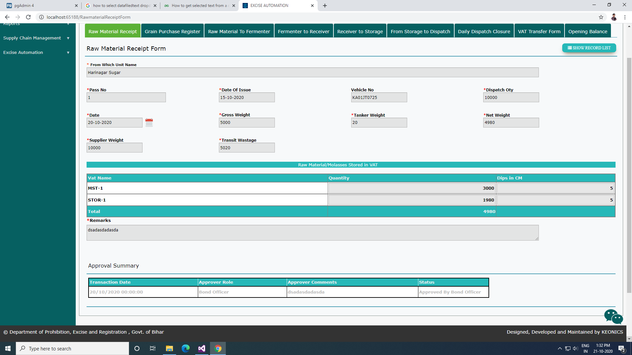

**Form Field and their Functionality**

*Date of Entry : User Input

From Which Unit : Readonly field

Vehicle No : Readonly field

Pass No : Readonly field

Pass Issue Date : Readonly field

Dispatch Qty : Readonly field

Gross Wt. : User Input

Tanker Wt. : User Input

Transit Wt. : User Input

*Supplier Wt. : User Input

Net Wt. : Readonly field

Remarks : User Input

**Grid Display**

Vat Name : User Input

Qty Stored : User Input. Number field only

**Validations required on the form**

Transit Wastage would be calculated field and not editable.

Net Weight = Gross Weight - Tanker Weight

Transit Wastage = Supplier Weight - Net Weight.

Supplier Wt. cannot be less than the dispatch Qty.

Gross weight can not be less than the supplier weight, if the Gross Weight entered by user is less than the supplier weight then system would prompt a message as (“Are you sure Gross weight enterd by you is correct as Gross Weight cannot be less than the supplier weight (Yes/No)?

The sum of the Qty Stored value in Grid should be equal to the dispatch qty.

# 3.2 Form 82 – (Raw Material to Fermenter)

This option is used by the applicant to enter the details of the Raw Material which are loaded into the Fermenter VAT. Once approved by the Bond Officer, the record will be locked and cannot be changed.

The various sections like Wash Setup, Wash Removed to Still, Spirit for Re-distillation and Spirit reproduced for Re-distillation will be minimized. The User can expand the section and enter data if necessary

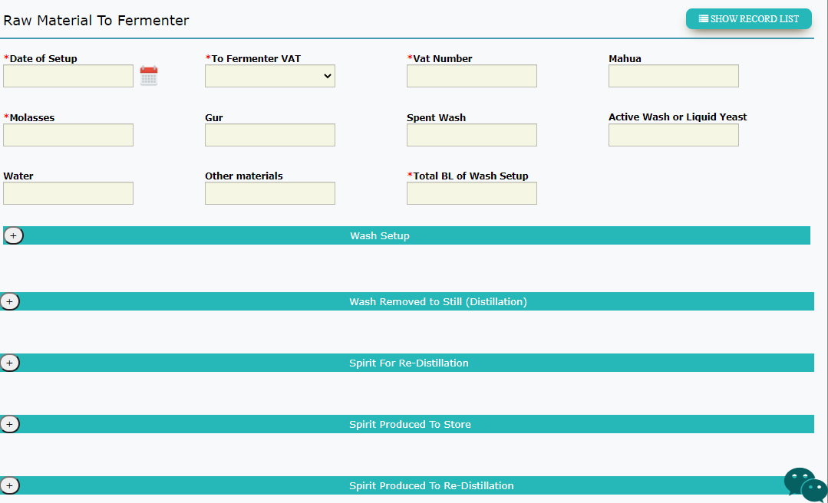

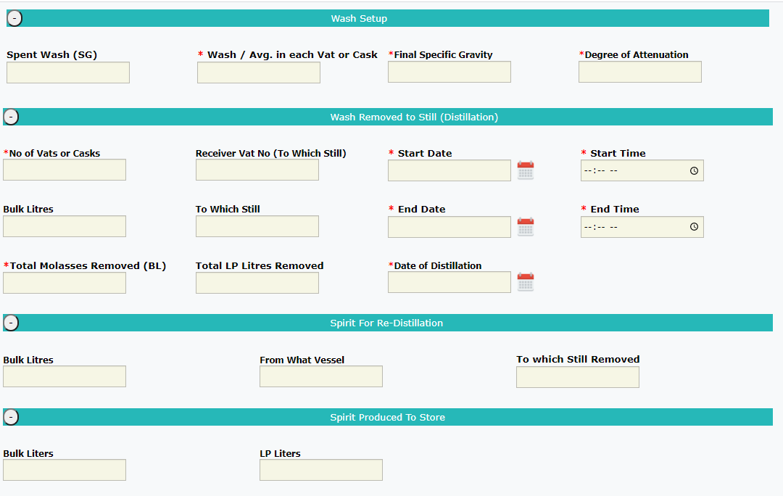

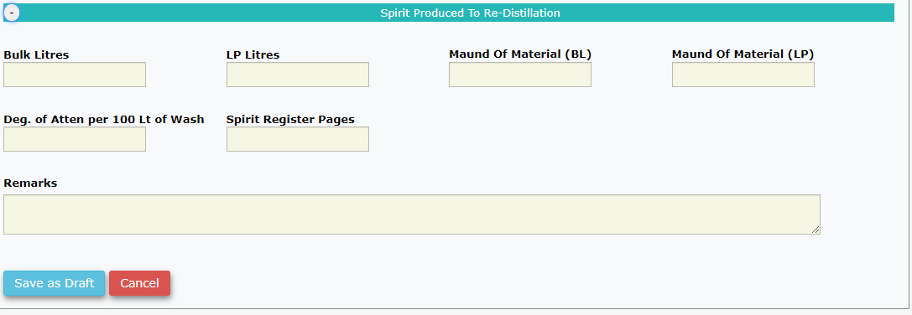

**Form Field and their Functionality**

*Date of Setup : User Input

Fermenter Vat : User Input The system will show the Fermenter Vats of the current login

No of each Vat : User Input. Data from the above field is copied

Mahua : User Input

Molasses : User Input

Gur : User Input

Spent Wash : User Input

Active Wash : User Input

Water : User Input

Other Materials : User Input

Total BL of Wash Setup : User Input

Sp. Gravity of Spent Wash : User Input

Sp. Gravity of each Wash : User Input

Final Sp. Gravity : User Input

No of Vat or Cask : User Input

Receiver Vat : User Input

Start of Distillation : User Input

Hour of Start : User Input

Bulk Litres : User Input

To which Still : User Input

End of Distillation : User Input

End of Distillation time : User Input

Total BL Removed : User Input

Total LP Removed : User Input

Distillation Date : User Input

Bulk Litres(Re-distillation) : User Input

From What Vessal : User Input

To which Still Removed : User Input

Bulk Litres (To Store) : User Input

LP Litres (To Store) : User Input

Bulk Litres(Produced for Re-distillation) : User Input

LP Litres(Produced for Re-distillation) : User Input

BL Per Maound of Materials : User Input

LP Per Maound of Materials : User Input

Degree of Attuenation (per 100) : User Input

Spirit Register Pages : User Input

Remarks : User Input

**Validations required on the form**

1. End Date cannot be less than Start Date
2. End time cannot be less than start time

# 3.3 Form 83 (Fermenter to Receiver)

This option is used by the Bond Officer to enter the Quantity of ENA / Ethanol received in the Receiver VAT after the process of distillation. These details are entered in Form 83.

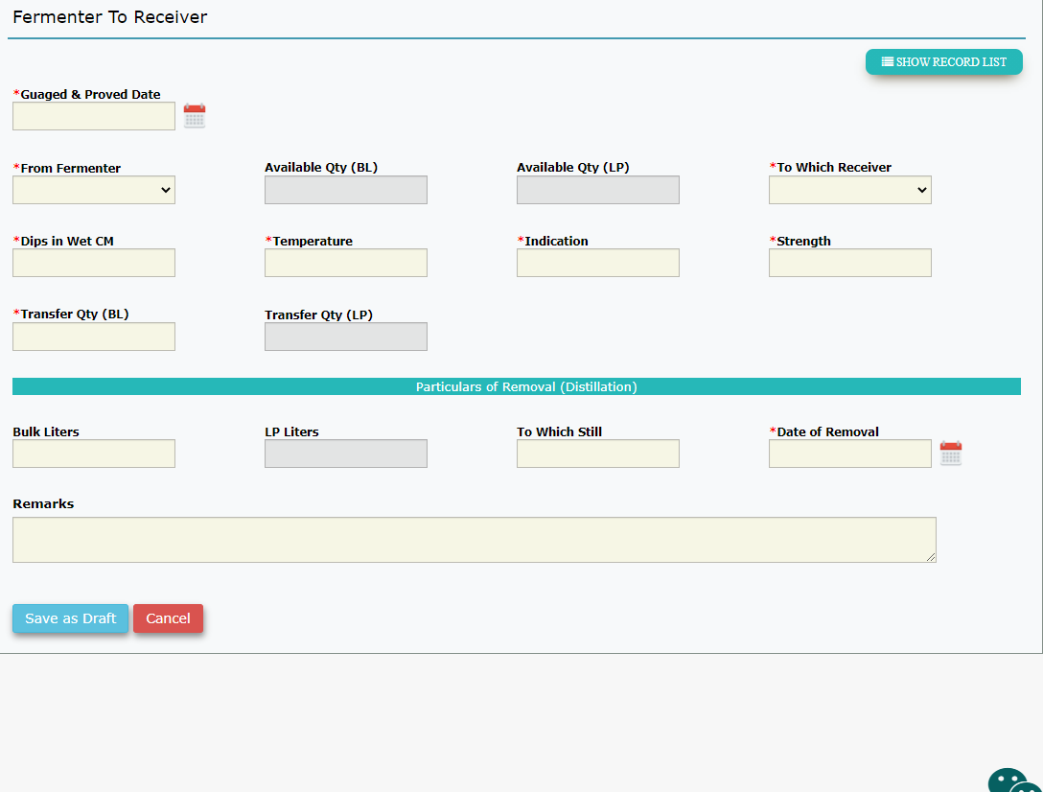

**Form Field and their Functionality**

*Gauged and Proved Date : User Input

*From Fermenter : User Input, Dropdown, Readonly

Available Qty (BL) : Readonly. Calculate the Qty in the Receiver VAT selected.

Available Qty (LP) : Readonly. Per calculation.

*Transfer Qty : User Input.

Transfer Qty (LP) : Readonly. Per calculation.

* Transfer to which Receiver : User Input, Dropdown

*Dips in Wet Cms : User Input

*Temperature : User Input

*Indication : User Input

*Strength : User Input

Bulk Litres (Distillation) : User Input

LP Litres (Distillation) : Calculated, Readonly

To Which Still : User Input

*Date of Removal : User Input

Remarks : User Input

**Validations required on the form**

LP Litres = (Bulk Litres * (1 + Strength/100))

e.g LP Litres = (1000 * (1+75/100)) = 1750

Whenever there is a change in the Strength field, all the LP Litres field on the form should be recalculated.

# 3.4 Form 84 (Receiver to Storage)

This Option is used by the Bond Officer to enter the details of the final product ENA / Ethanol after the Quality Inspection is done in the Receiver VAT. The Final products are stored in the Storage VAT. The Bond officer will note the Quantity moved from Receiver VAT to Storage VAT.

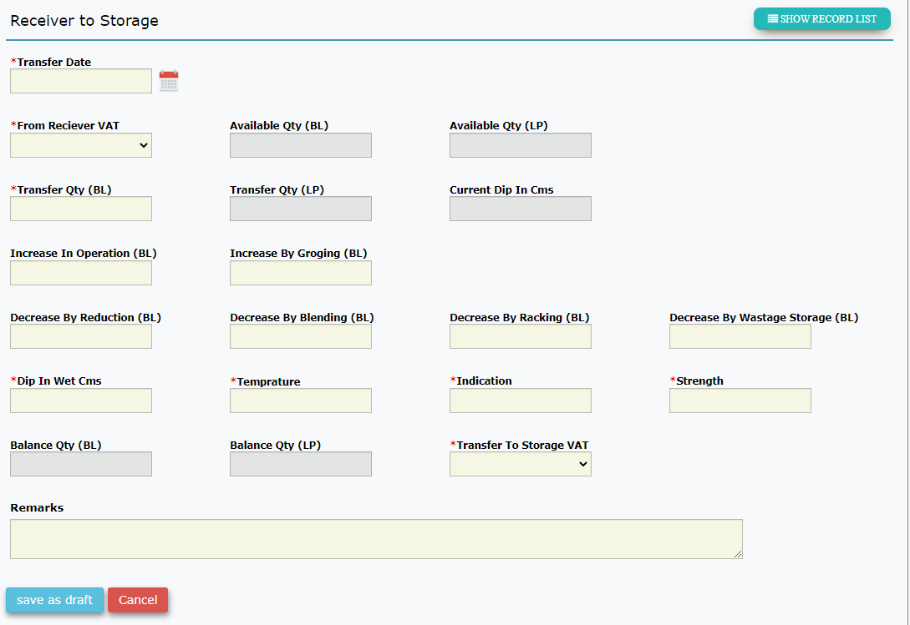

**Form Field and their Functionality**

*Date and Hour of Transfer : User Input, Required.

*From Receiver VAT : User Input, Dropdown.

Available Qty (BL) : Readonly. Calculate the Qty in the Receiver VAT selected.

Available Qty (LP) : Readonly. Per calculation.

*Transfer Qty : User Input.

Transfer Qty (LP) : Readonly. Per calculation.

Current Dips in Wet Cms : Readonly.Pick the last Dip entered for this receiver in form 83 or user input. Check this ??

Inc BL in Operations : User Input

Inc BL by Groging : User Input

Decrease by Reduction : User Input

Decrease by Blending : User Input

Decrease by Racking : User Input

Decrease by Wastage : User Input

*Dips in Wet Cms : User Input

*Temperature : User Input

*Indication : User Input

*Strength : User Input

Balance BL Qty : Readonly. Calculated

Balance LP Qty : Readonly. Calculated per LP Calculation

*Transfer to Storage VAT : Dropdown.

Remarks : User Input

**Validations required on the form**

Transfer Qty can be less than or equal to Available Qty

Balance BL Qty =

Available Qty – Transfer Qty

+ (Inc in Operations + Inc in Groging)

– (Deficiency in Reduction + Blending + Racking + Wastage)

Balance LP Qty will be likewise calculated depending on the strength entered.

LP Litres = (Bulk Litres * (1 + Strength/100))

e.g LP Litres = (1000 * (1+75/100)) = 1750

Whenever there is a change in the Strength field, the Balance Qty LP Litres field on the form should be recalculated.

# 3.5 Form 84D (From Storage to Dispatch)

The Final products are stored in the Storage VAT and Dispatched through the Dispatch VAT. The Bond officer will record the Quantity moved from Storage VAT to Dispatch VAT.

The Date mentioned in the “Date and Hour” field is the date of transfer

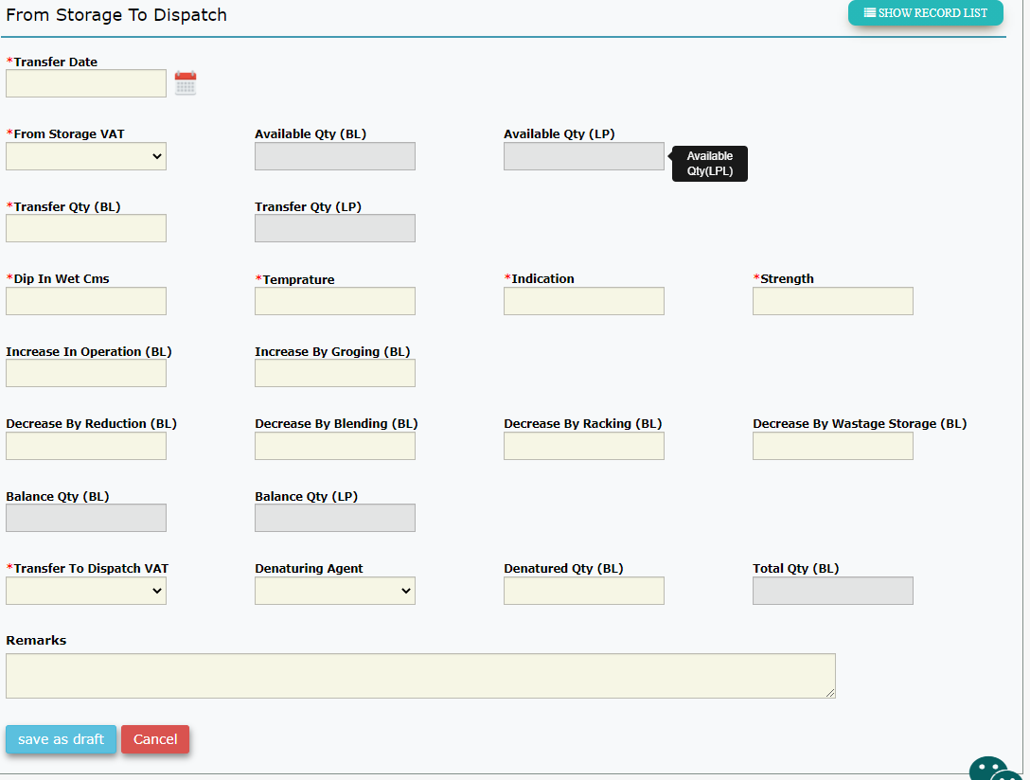

**Form Field and their Functionality**

*Date and Hour of Transfer : User Input, Required.

*From Storage VAT : User Input, Dropdown.

Available Qty (BL) : Readonly. Calculate the Qty in the Storage VAT selected.

Available Qty (LP) : Readonly. Per calculation.

*Transfer Qty (BL) : User Input.

Transfer Qty (LP) : Readonly. Per calculation.

*Dips in Wet Cms : User Input

*Temperature : User Input

*Indication : User Input

*Strength : User Input

Inc BL in Operations : User Input

Inc BL by Groging : User Input

Decrease by Reduction : User Input

Decrease by Blending : User Input

Decrease by Racking : User Input

Decrease by Wastage : User Input

Balance BL Qty : Readonly. Calculated

Balance LP Qty : Readonly. Calculated per LP Calculation

*Transfer to Dispatch VAT : Dropdown.

Name of Denaturing Agent : Dropdown, User Input

Denatured Qty (BL) : User Input

Total Qty (BL) : Readonly. Calculated.

Remarks : User Input

**Validations required on the form**

1. Transfer Qty can be less than or equal to Available Qty
2. Balance BL Qty = Available Qty – Transfer Qty + (Inc in Operations + Inc in Groging) – (Deficiency in Reduction + Blending + Racking + Wastage)

Balance LP Qty will be likewise calculated depending on the strength entered.

LP Litres = (Bulk Litres * (1 + Strength/100))

e.g LP Litres = (1000 * (1+75/100)) = 1750

Whenever there is a change in the Strength field, the Balance Qty LP Litres field on the form should be recalculated.

When the user enters the Denatured Qty and if the Denatured Agent is not in liquid form (e.g. Powder) then the system **should not increase** the **Total Qty** field. **CHECK ??. As mentioned by the customer**

# 3.5 Daily Dispatch Closure

This option is used by the Bond officer to enter all the Dispatch details of the day. The system will calculate the total Qty dispatched for any given day and dispatch VAT selected.

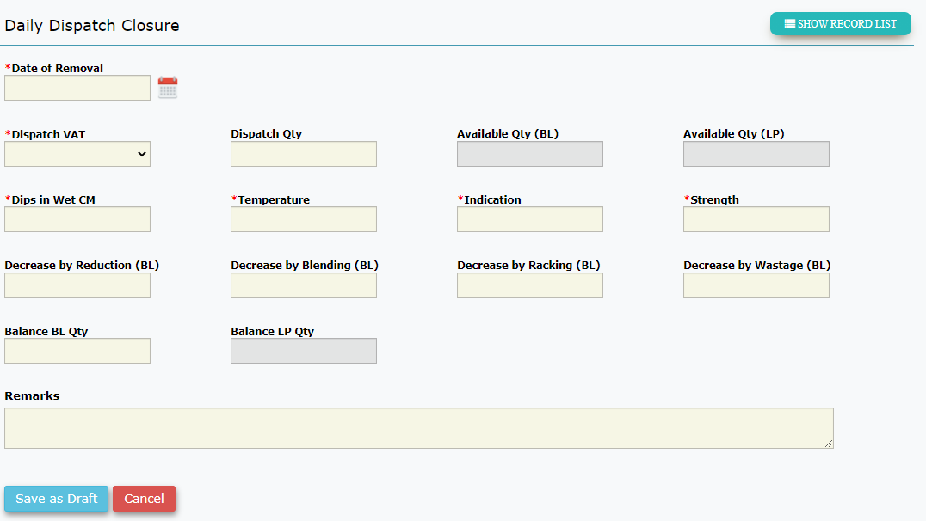

**Form Field and their Functionality**

*Date of Removal : User Input, Required.

*Dispatch VAT : User Input, Dropdown.

*Dispatch Qty : User Input

Available Qty (BL) : Readonly. Calculate the Qty in the Dispatch VAT selected.

Available Qty (LP) : Readonly. Per calculation.

*Dips in Wet Cms : User Input

*Temperature : User Input

*Indication : User Input

*Strength : User Input

Decrease by Reduction : User Input

Decrease by Blending : User Input

Decrease by Racking : User Input

Decrease by Wastage : User Input

Balance BL Qty : Readonly. Calculated

Balance LP Qty : Readonly. Calculated per LP Calculation

Remarks : User Input

**Validations required on the form**

1. Dispatched Qty should be less than or equal to Available Qty
2. Balance BL Qty = Available Qty – Dispatched Qty – (Decrease in Reduction + Blending + Racking + Wastage)
3. Balance LP Qty will be likewise calculated depending on the strength entered.